**IoT Based Air Quality Monitoring System**

**why we need air quality systems:**

**Air quality systems are essential for monitoring and controlling the quality of air in indoor and outdoor environments. They help to detect and measure the concentration of pollutants in the air, such as particulate matter, nitrogen oxides, sulfur dioxide, and ozone. This information is then used to inform public health policies and regulations, as well as to develop strategies for reducing air pollution.**

**For instance, Oizom offers end-to-end and scalable solutions for real-time air quality monitoring and advanced data analytics. Their range of air monitoring systems monitors various environmental parameters like air quality, polluting gases, odourful and toxic gases, noise, weather conditions, radiation, etc. Using their patented e-breathing technology, Oizom assures the highest accuracy even in extreme environmental conditions.**

### **Components Required**

* **Nova PM Sensor SDS011**
* **0.96’ SPI OLED Display Module**
* **DHT11 Sensor**
* **MQ-7 Sensor**
* **Jumper Wires**

### **Air Quality Index Calculation**

The [AQI in India](https://cpcb.nic.in/displaypdf.php?id=bmF0aW9uYWwtYWlyLXF1YWxpdHktaW5kZXgvQWJvdXRfQVFJLnBkZg==) is calculated based on the average concentration of a particular pollutant measured over a standard time interval (24 hours for most pollutants, 8 hours for carbon monoxide and ozone). For example, the AQI for PM2.5 and PM10 is based on 24-hour average concentration and AQI for Carbon Monoxide is based on 8-hour average concentration). The AQI calculations include the eight pollutants that are PM10, PM2.5, Nitrogen Dioxide (NO2), Sulphur Dioxide (SO2),Carbon Monoxide (CO), ground-level ozone (O3), Ammonia (NH3), and Lead (Pb). However, all of the pollutants are not measured at every location.

Based on the measured 24-hour ambient concentrations of a pollutant, a sub-index is calculated, which is a linear function of concentration (e.g. the sub-index for PM2.5 will be 51 at concentration 31 µg/m3, 100 at concentration 60 µg/m3, and 75 at a concentration of 45 µg/m3). The worst sub-index (or maximum of all parameters) determines the overall AQI.

**Block diagram:**

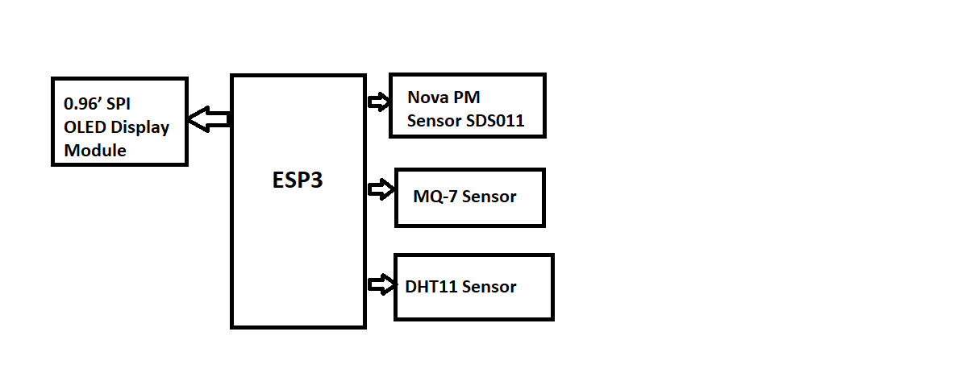

### **Circuit Diagram**

**The circuit diagram for IoT Based Air Quality Monitoring System is very simple and given below:**

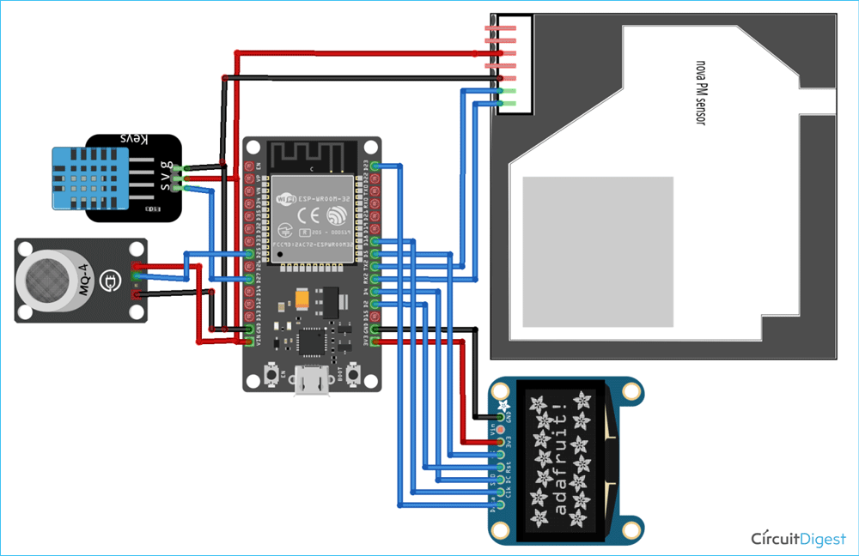

**SDS011 Sensor, DHT11, and MQ-7 sensor are powered with +5V while the OLED Display module is powered with 3.3V. The transmitter and Receiver pins of SDS011 are connected to GPIO16 & 17 of ESP32. The Analog Out pin of the MQ-7 sensor is connected to GPIO 25 and the data pin of the DHT11 sensor is connected to the GPIO27 sensor. Since the OLED Display module uses SPI communication, we have established an SPI communication between the OLED module and ESP32. The connections are shown in the below table:**

| **S.No** | **OLED Module Pin** | **ESP32 Pin** |
| --- | --- | --- |
| **1** | **GND** | **Ground** |
| **2** | **VCC** | **5V** |
| **3** | **D0** | **18** |
| **4** | **D1** | **23** |
| **5** | **RES** | **2** |
| **6** | **DC** | **4** |
| **7** | **CS** | **5** |
| **S.No** | **SDS011 Pin** | **ESP32 Pin** |
| **1** | **5V** | **5V** |
| **2** | **GND** | **GND** |
| **3** | **RX** | **17** |
| **4** | **TX** | **16** |
| **S.No** | **DHT Pin** | **ESP32 Pin** |
| **1** | **Vcc** | **5V** |
| **2** | **GND** | **GND** |
| **3** | **Data** | **27** |
| **S.No** | **MQ-7 Pin** | **ESP32 Pin** |
| **1** | **Vcc** | **5V** |
| **2** | **GND** | **GND** |
| **3** | **A0** | **25** |

**conclusion**

[**Good air quality is important for health and wellbeing**](https://www.bing.com/ck/a?!&&p=a0ea0e8e23c368abJmltdHM9MTY5NjcyMzIwMCZpZ3VpZD0xYTdiOWM3YS02ZDc1LTZlNWEtMzM4OC04ZjQwNmNhNzZmYzgmaW5zaWQ9NTY1NQ&ptn=3&hsh=3&fclid=1a7b9c7a-6d75-6e5a-3388-8f406ca76fc8&psq=importance+of+good+air+quality&u=a1aHR0cHM6Ly9mb29ib3QuaW8vZ3VpZGVzL3doeS1pYXEtaXMtaW1wb3J0YW50LnBocA&ntb=1)**.** [**Poor air quality can cause severe health problems such as asthma, cardiovascular diseases, and even cancer**](https://www.bing.com/ck/a?!&&p=2d0306b3ca61e6fbJmltdHM9MTY5NjcyMzIwMCZpZ3VpZD0xYTdiOWM3YS02ZDc1LTZlNWEtMzM4OC04ZjQwNmNhNzZmYzgmaW5zaWQ9NTY1OQ&ptn=3&hsh=3&fclid=1a7b9c7a-6d75-6e5a-3388-8f406ca76fc8&psq=importance+of+good+air+quality&u=a1aHR0cHM6Ly93d3cudHJhbnNwb3J0ZW52aXJvbm1lbnQub3JnL2NoYWxsZW5nZXMvYWlyLXF1YWxpdHkvd2h5LWlzLWFpci1xdWFsaXR5LXNvLWltcG9ydGFudC8&ntb=1)**.** [**Good indoor air quality means comfortable temperature and humidity, ample ventilation, and control of pollutants**](https://www.bing.com/ck/a?!&&p=6bc61f5cac2cf1fbJmltdHM9MTY5NjcyMzIwMCZpZ3VpZD0xYTdiOWM3YS02ZDc1LTZlNWEtMzM4OC04ZjQwNmNhNzZmYzgmaW5zaWQ9NTY2MQ&ptn=3&hsh=3&fclid=1a7b9c7a-6d75-6e5a-3388-8f406ca76fc8&psq=importance+of+good+air+quality&u=a1aHR0cHM6Ly93d3cucnNpLmVkdS9ibG9nL2h2YWNyL3RoZS1pbXBvcnRhbmNlLW9mLWluZG9vci1haXItcXVhbGl0eS8&ntb=1)**.** [**Humans tend to spend a large amount of time indoors, and breathable air that’s free of health-threatening pollutants can lead to a higher quality of life, lower risk of respiratory illnesses, and a reduced risk of various chronic conditions**](https://www.bing.com/ck/a?!&&p=f75764b4d50ec422JmltdHM9MTY5NjcyMzIwMCZpZ3VpZD0xYTdiOWM3YS02ZDc1LTZlNWEtMzM4OC04ZjQwNmNhNzZmYzgmaW5zaWQ9NTY2Mw&ptn=3&hsh=3&fclid=1a7b9c7a-6d75-6e5a-3388-8f406ca76fc8&psq=importance+of+good+air+quality&u=a1aHR0cHM6Ly9mb29ib3QuaW8vZ3VpZGVzL3doeS1pYXEtaXMtaW1wb3J0YW50LnBocA&ntb=1)**.** [**Some of the most common health effects of poor air quality include irritation of eyes, throat, and lungs**](https://www.bing.com/ck/a?!&&p=fbe2415c57118714JmltdHM9MTY5NjcyMzIwMCZpZ3VpZD0xYTdiOWM3YS02ZDc1LTZlNWEtMzM4OC04ZjQwNmNhNzZmYzgmaW5zaWQ9NTY2NQ&ptn=3&hsh=3&fclid=1a7b9c7a-6d75-6e5a-3388-8f406ca76fc8&psq=importance+of+good+air+quality&u=a1aHR0cHM6Ly9lbnZpcm9ubWVudC5nb3Z0Lm56L2ZhY3RzLWFuZC1zY2llbmNlL2Fpci93aHktYWlyLXF1YWxpdHktbWF0dGVycy8&ntb=1)**.**